COVID-19 Health and Safety Q & A

What happens if a staff member or volunteer tests positive for COVID-19?
As soon as we are notified, we immediately start contact tracing. We follow all SF guidelines involving COVID-19 and contact tracing in the workplace.

How does contact tracing work?
We take privacy very seriously. For contact tracing to work, individuals must trust their information will be kept confidential so they can be completely honest. We always start by reassuring people that their information will be kept confidential and explaining the definitions of important terms, such as close contact.

Next, we establish a timeline. We want to understand when they tested positive, the date of their test, and when symptoms started (if they have symptoms) so we can determine the infectious period. Once we have a clear timeline, we ask about where they were in the workplace, what facilities were used, what equipment was used, who they were working with and around, and if they believe they were in close contact with anyone (staff, volunteers, or participants) during their infectious period.

You mentioned some terms like close contact and infections period. What do those mean?
There are a few terms people need to know:
- Close contact: Being within 6 feet of a person with COVID-19 for any period of time that adds up to 15 minutes or more in a 24-hour period, masked or unmasked, while that person was contagious. Close contact also includes having direct contact for any amount of time with the body fluids of the person with COVID-19. For example, was coughed or sneezed on, shared utensils with, or was provided care or provided care for them without wearing a mask, gown, and gloves.

- Infectious period: The infectious period refers to the time period in which someone is contagious or can spread the virus to others. People with COVID-19 are considered contagious starting 48 hours before their symptoms began until 1) at least 10 days have passed since their symptoms began, 2) they have not had a fever for at least 24 hours AND 3) their symptom have improved. If the person with COVID-19 never had symptoms, they are considered contagious starting 48 hours before their positive COVID-19 test was collected until 10 days after they were tested.

- Isolation vs Quarantine: These terms are used to describe the act of separating an individual from others in order to stop the transmission or potential transmission of COVID-19 to others. Isolation is for individuals who currently have a COVID-19 infection or COVID-19 symptoms. Quarantine is for individuals who have been identified as coming into close contact with an individual with COVID-19 and are at risk of becoming contagious. The goal of both isolation and quarantine is to keep infected or potentially infected individuals from others to stop the spread of the virus.

What if I test positive and I’m not sure if I was in close contact with someone? Or what if I can’t remember a close contact’s name or don’t know how to contact them?
If you aren’t sure we err on the side of caution. For example, if you remember talking to someone, but aren’t sure if you spoke to them for 5 minutes or 15, we’d consider that person a close contact to be safe.

If you don’t know someone’s name or how to contact them, then we start investigating. We will ask for a description of the person, what roles they are in, what context you met them in, etc. Then we may
contact the supervisor to get a list of people who were on site to try to figure it out. So far, we haven’t had any instances of not being able to identify someone. This is why it’s important to have volunteers sign in.

What happens after the interview?
The individual is instructed on next steps, how to safely isolate, where they can find resources, emergency symptoms to look out for, etc. Then, we immediately notify any identified ‘close-contacts’ of the need to quarantine, next steps, where they can find support, etc. Once all of those individuals have been notified, a General Exposure Advisory is sent to all staff and volunteers who were on-site during the individual’s infectious period as soon as possible.

Why don’t you contact everyone who was onsite to find out where they went and if they could have been near the person who tested positive.
This is a question we hear a lot. We don’t do this because the most important thing is to make sure close contacts are notified so they can quarantine. Contacting everyone who could have been onsite isn’t the best way to identify close contacts quickly, and it is hard to do while still maintaining privacy. It is important to remember, just because you were in the same building or at the same worksite as someone with COVID, does not mean you were in close contact with them.

Part of why we send out the General Exposure Advisory is to make sure everyone who was onsite knows there was a positive case so they can monitor for symptoms, even if they weren’t identified as a close contact. We also want staff and volunteers to be as informed as possible. And of course, if you are worried for any reason, go get a COVID test.

How do you balance confidentiality with making sure you gather and share enough information to keep people safe?
Contact tracing is a delicate balance between public good (health of the public) and the rights of individuals. It only works if people are honest and many people won’t be completely honest if they don’t trust the us. This is why confidentiality is so important. The information you share during contact tracing will only be shared with the people who need to know for the purposes of contact tracing, isolation, and quarantine. Contacts who are identified will be told they've been exposed to someone who's infectious, but they will not be told who.

The assurance of privacy and confidentiality will allow for a more informative interview and successful contact tracing.

Why don’t we shut down after a positive case? How is the Food Bank making sure people are safe? The Food Bank is taking safety very seriously and we are following all COVID-19 safety guidance and health orders from the San Francisco Department of Public Health, Marin Health and Human Services, and California Department of Public Health. Because the Food Bank is an essential business, we are not required to shut down after someone who tested positive was onsite. We immediately start contact tracing and follow all COVID-19 response guidelines. We also arrange a very thorough cleaning of any workspaces or areas the individual was in.

This is in addition to other safety protocols we go through daily. Those include daily health checks, cleaning and disinfecting protocols, upgraded ventilation system in our facilities, requiring masks indoors, social distancing indoors, and establishing max capacities for indoor facilities.

Anything else people should know about staying safe?
The response to COVID-19 is very time sensitive. If you have symptoms, please isolate right away.

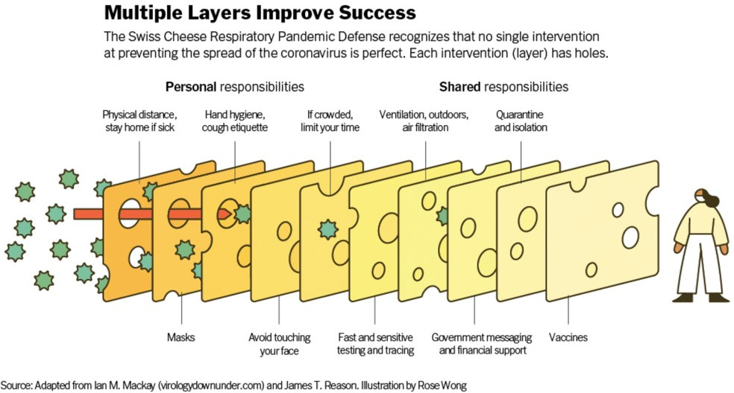
It will take a combination of efforts to help keep us all safe. Some people have referred to this as the swiss cheese model:

What should I do if I’m having symptoms but waiting for test results? How early do you want to know?
You will need to start isolation right away in order to reduce the possibility of spreading the virus. If you have a volunteer shift with us, please let us know. Please do not come to your volunteer shift if you are feeling sick. Our Health and Safety Officer can provide you with information on where to get a COVID-19 test and what your next steps should be.

Since COVID-19 has similar symptoms to the flu, the common cold, and some seasonal allergies, what are your recommendations for how to identify symptoms?
This is part of why COVID-19 can be so difficult to detect. The SF Department of Public Health (SFDPH) says you should look out for any new or unexplained symptoms. So, think about how out of the norm your symptoms are. And if you are unsure, you should err on the side of caution – stay home, get a test, and come back when you know for sure that you are not contagious.

Anything else we should know about contact tracing?
Just for some historical context, contact tracing is an established public health tool that has been used as an official strategy since the mid-19th century to break the chain of transmission of communicable diseases and to protect communities. It is used as a tool around the globe daily as a way to help stop the spread of infectious diseases such as tuberculosis, Ebola, vaccine-preventable infections like measles and smallpox, STI’s, and novel infections (like COVID-19 and SARS). The history of contact tracing is a contentious one, with concerns around privacy and misuse of information paving the way for the public mistrust of a very important public health tool. We say all of that to say, contact tracing is not perfect and it has its limitations, but it is still one of the most effective tools we have to help keep our communities safe from COVID-19.

COVID-19 Resources:

Testing:
Find out about your COVID-19 testing options | San Francisco (sf.gov)
COVID-19 Testing | Marin County Coronavirus Information (marinhhs.org)

Vaccination:
COVID-19 vaccine in San Francisco | San Francisco (sf.gov)
COVID-19 Vaccine | Marin County Coronavirus Information (marinhhs.org)

Coronavirus Disease 2019 (COVID-19) | CDC

California Department of Public Health (ca.gov)

Coronavirus in Marin County | Marin County Coronavirus Information (marinhhs.org)

COVID-19 -- San Francisco Department of Public Health (sfdph.org)

